|  |  |  |
| --- | --- | --- |
| **Gather Materials about Candidates**  ***Sources of information may include:***   * Campaign literature * Candidate websites and social media * Ads (radio, television, mailings) * Information about candidate’s parties and platforms * Candidate speeches * Candidate debates and forums | **2024 Election Dates**  ➢**August 20**   * Primary partisan elections for federal, state and countywide offices * Nonpartisan elections for school board, circuit court judges and county court judges   ➢**November 5**  • | **Choosing**  **Candidates in Florida** |

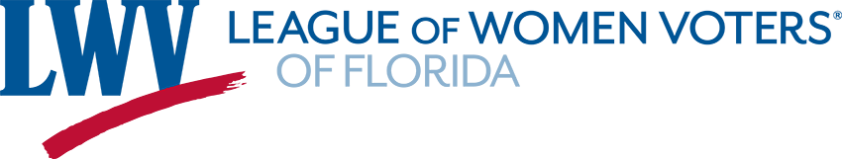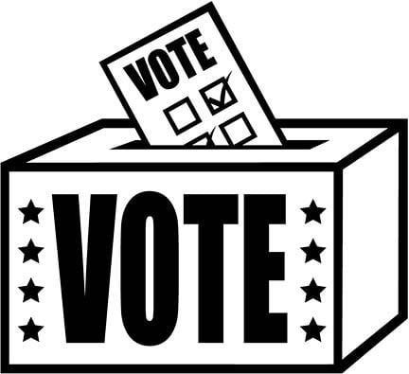General election for federal, state and countywide offices

***Nonpartisan sources of information:*** • Run-off elections for school board

* **Vote411.org**: Personalized voting and judges, if necessary information sponsored by LWV • Florida Constitutional Amendments Education Fund • Judicial Merit Retention Questions
* **Ballotpedia.org/Florida**:

Ballotpedia is a 501(c)3 charitable

nonprofit organization and is not The League of Women Voters (LWV) was founded over 100 years ago to educate affiliated with any campaigns or

voters and promote democracy. The League

candidates for office. remains nonpartisan, never endorsing or

|  |  |
| --- | --- |
| • **GovTrack.us**: Publishes information about your | opposing any candidate for public office. |

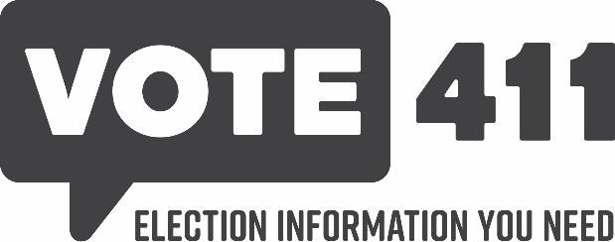representative and senators in https://lwvfl.org

Congress including voting records.P.O. Box 1911

Orlando, FL 32802

(407) 377-5777

**VOTE** for the candidates who support **YOUR** values & goals.

# Take a Look at Campaign Information

* ***TV and Radio Ads:*** What did you learn about the candidate from the ad? Find out what you can about the **facts** as well.
* ***Pamphlets, Flyers, Websites:*** Valid, substantive information or distortions and evasions.
* ***Political Party and Party Platform***: A candidate’s party may take a stand on issues that you care about, but has the candidate addressed the issues directly?

# Spot Phony Issues

* ***Passing the Blame:*** When one candidate accuses another party or candidate of being the cause of a major problem, fact check the statements.
* ***Promising the Sky:*** These are unrealistic promises that no elected official could fulfill.
* ***Evading Real Issues:*** Watch our for candidates who talk about benefits and never mention costs or details of how the program will work.

# Learn How Others View the Candidate

* ***Seek the opinions of others in the community:*** Find out who they support and why. What shaped their political opinions?
* ***Learn about endorsements:*** Endorsements provide clues to the issues a candidate supports.
* ***Look into campaign contributions:*** Where id the candidate get the funds to finance their campaign? How might these contributions affect the candidate’s conduct in office?

# Recognize Distortion Techniques Rate the Candidates on How They

* ***Name-Calling/Appeals to Prejudice:*** These are **Campaign** attacks on an opponent based on characteristics • The way a candidate runs a campaign can that will not affect performance in office. provide important clues as to how that
* ***Loaded Statements:*** “I oppose wasteful candidate will perform as a public official, once spending” doesn’t say much - and it implies that elected.

the candidate’s opponent favors it. • A candidate who runs an open, issues-oriented

* ***Catchwords:*** Beware of empty phrases, such as campaign can be expected to become an “law and order” … “the American way” that are accessible, forthright and thoughtful public designed to trigger knee-jerk, emotional official.

reactions rather than to inform. • Is the candidate willing to debate with opponents and meet regularly with the press?

# Be Smart About Political Polls

Before you believe everything you read in political **FINALLY - Sorting It All Out** poll results, ask these questions. • Which candidate understands the current issues

facing the country, state, county, city or school

* ***Who sponsored the poll?*** When parties and

board? candidates pay for polls, they might not publish

unfavorable data. • Which candidate’s views on the issues did you

agree with the most? • ***What questions were asked?*** Were they slanted? You can spot blatantly biased • Who ran the fairest campaign?

questions, but also look for ones that subtly • Which candidate was most knowledgeable on steer a respondent to a certain answer or leave the issues you care about the most?

no room for a “Yes, if …” or a “No, but …”

* Which candidate has the leadership qualities • ***Who and how many were interviewed?*** How you are looking for? were respondents selected? The selection needs to be random or at least represent all segments of the population proportionately. The smaller the sample of respondents, the wider the margin of error in the findings.

